# Materials Studio Computational Chemistry Workflow

## Steve Monaco

## May 25, 2018

## Description

A collection of scripts that allow for high-throughput CASTEP calculations through Materials Studio and retrieval of results. From a set of crystalline input structures, you can perform crystalline-only, molecule-in-a-box-only, or a crystalline with a secondary molecule-in-a-box calculation using the crystalline’s resultant structure.

## Script Installation

1. Copy **SetupStructureTable.pl** and **CalculateStructureTable.pl** into your Materials Studio script folder. The default location is **C:\Users\{YourUserName}\Documents\Materials Studio** **Projects\My Favorites**. Verify that Materials Studio can access the scripts via the menu option **Tools → Scripting → Library…** or **User → Library…**

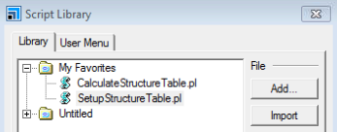

1. While inside of **Script Library**, select the **User Menu** tab. **Insert** a **Group** and name it **High-Throughput Table Scripts**. **Insert → Command** twice and configure as shown below.

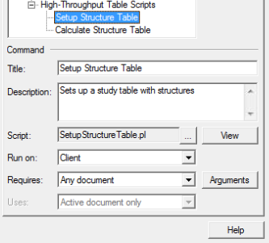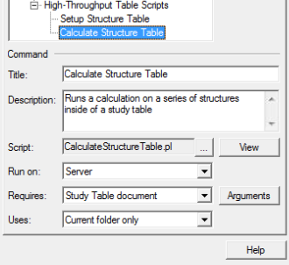

1. Now enter the **Arguments** dialog to add and configure the following arguments for each script:

|  |  |  |
| --- | --- | --- |
| Setup Structure Table | | |
| Table_Prefix_Name | String |  |
| Path_To_Structures | String |  |
| Structures_Per_Table | Integer | 10 |
| Crystal_Settings_Name | String |  |
| MIB_Settings_Name | String |  |
| Create_MIB_Table | Boolean | No |
| MIB_Nearest_Neighbor_Distance | Floating point | 20.0 |

|  |  |  |
| --- | --- | --- |
| Calculate Structure Table | | |
| Perform_Geometry_Optimization | Boolean | Yes |
| Retrieve_Band_Structure | Boolean | Yes |
| Retrieve_Polarizability | Boolean | Yes |
| Primary_Settings_Name | String |  |
| Perform_Secondary_MIB_Calculation | Boolean | Yes |
| MIB_Nearest_Neighbor_Distance | Floating point | 20.0 |
| Secondary_MIB_Settings_Name | String |  |

## Script Usage

1. Obtain structures (**.xsd**, **.mol**, or **.cif**) and store them in a single folder external to the project.

**Recommendation**: Store your initial structures in the parent directory of your Materials Studio project’s Documents folder (e.g. **C:\Chemistry\ChemWorkflow_Files\YourStructureSet\** if your project’s Documents folder is **C:\Chemistry\ChemWorkflow_Files\Documents\**). This attaches your original source structures project and prevents them from being lost and forgotten during project archival.

1. Create settings for the calculations you wish to perform. You can also copy the **.xms** file from another project (e.g. **SMCastep_Extension_PAHOpt.xms**) into the **Documents** root directory of your MS project. To create a new settings file, configure your CASTEP calculation and calculated properties, and click the **Save Settings** dropdown as shown below. If you are doing a crystalline and secondary MIB calculation, you must create two separate settings.

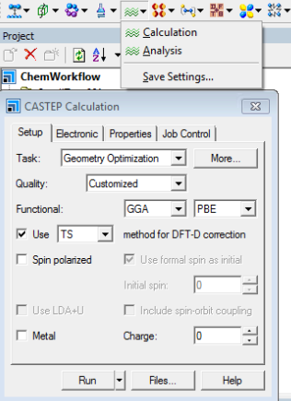

1. Open the **SetupStructureTable** script via the menu option **User → High-Throughput Table Scripts → Setup Structure Table**. (**Caution**: Due to how MS works, you must have a document open (study table, 3d structure, etc.) in the background before you can select a script.) The parameter table below describes how to configure the script for a crystalline-only import. (**Warning**: The **Path_To_Structures** property must end with a trailing \ character.)

|  |  |  |
| --- | --- | --- |
| Setup Structure Table | | |
| Parameter | **Description** | **Crystalline-only Example Value** |
| Table_Prefix_Name | Name prefixed to each outputted study table | PAHSet |
| Path_To_Structures | Folder containing structures | **C:\Chemistry\ChemWorkflow_Files\PAHSet\** |
| Structures_Per_Table | Number of structures in each outputted study table | 10 |
| Crystal_Settings_Name | Settings for a crystalline calculation. Not required for a MIB-only calculation. | PAHOpt |
| MIB_Settings_Name | Settings for a MIB calculation. Required for both MIB-only and secondary MIB calculations. |  |
| Create_MIB_Table | Creates a separate table with MIB structures. Required for a MIB-only calculation | Unchecked |
| MIB_Nearest_Neighbor_Distance | Distance between molecules in an MIB structure | 20.0 |

1. Open the **Script Job Control** dialog via the menu option **User → Script Job…** and configure the server and number of cores calculations will use.
2. Open the generated study table document that you wish to calculate.
3. Open the **CalculateStructureTable** script via the menu option **User → High-Throughput Table Scripts → Calculate Structure Table**. The parameter table below describes how to configure the script for a crystalline-only calculation.

|  |  |  |
| --- | --- | --- |
| Calculate Structure Table | | |
| Parameter | **Description** | **Crystalline-only Example Value** |
| Perform_Geometry_Optimization | If unchecked, the Energy task will be used instead | ✓ |
| Retrieve_Band_Structure | Retrieves results from a band structure calculation. | ✓ |
| Retrieve_Polarizability | Retrieves results from a polarizability calculation | ✓ |
| Primary_Settings_Name | Name of settings used for the first calculation. Used for crystalline-only, MIB-only, and crystalline with secondary MIB calculation runs. | PAHOpt |
| Perform_Secondary_MIB_Calculation | If checked, the script will create a MIB structure using the primary calculation’s resultant structure and perform a secondary calculation on it. | x |
| MIB_Nearest_Neighbor_Distance | Distance used to generate the secondary MIB structures | 20.0 |
| Secondary_MIB_Settings_Name | Name of settings used for secondary MIB calculations. These settings **must** calculate the same properties as the crystalline settings because the script will attempt to retrieve the same properties from both. | (Leave field empty) |

## Comments

* The script does not report progress back to the Materials Studio client until the job is finished. You must view the job in **Remote View** and inspect it manually to determine the progress. The **CalculateStructureTable.pl.out** file contains information on the structure being currently processed along with serious errors that cancel a calculation. For more detailed information, inspect the **.castep** file for the currently running calculation.

## Revision History

|  |  |  |
| --- | --- | --- |
| Date | Editor | Major Changes |
| 5-25-18 | SMonaco | Initial version. |